**Inundation Zone Prep Workflow**

**Data Management Process:**

Run SQL query to generate table of shapefile attachments with detailed attributes.

“shapefile id” UID/PK Attribute: [damid]-[studyid]-[attid]

This attribute will uniquely identify an attachment. Process tracking should be tied to this PK.

**Options to filter out any records that have already been processed:**

1. Inside download query: @lastRun date = ‘2022-08-05’
2. Can use attid or shapefieldid from previous tracking spreadsheet to do a “not in list” filter: “at.id not in (1,2,3,4,etc)”

**Fields Manually Entered during data prep:**

|  |  |  |
| --- | --- | --- |
| **Field** | **Example Data** | **Description** |
| InvNum | 123456 |  |
| Att_id | 77000 |  |
| Type | PMF | Acronym for flood scenario (e.g. PMFwBr, PMF, SunDayBr, etc) ALSO: SL – screening level |
| SDF_Info | 100-yr | inflow design storm utilized for SDF if applicable |
| GIS_Prep_Date | 6/20/2023 | Date of GIS Prep |
| Prepped_By | AK | Initials of staff who performed prep |

Geoprocessing Tool Steps:

*note these steps are automated and batched by folder in the latest custom geoprocessing toolbox.*Note: Right click on the geoprocessing tool and select batch in order to speed up the process by running tool on multiple layers sequentially. Make sure to use names that you will remember what they mean. In file naming %Name% will be part of the old file name so use name such as “Proj_%Name%” to keep track of layers after a batch projection.

1. (Conditional) Line to Polygon (only if file in line format)
   1. Only if applicable – hopefully already in polygon format. If in line format may require additional tweaking to work but try this tool
2. Project
   1. Project from existing projection to WGS 1984 Web Mercator (auxiliary sphere) EPSG 387
3. Dissolve
   1. If multiple features in attribute table, or just dissolve all layers to be sure
   2. Do not select a dissolve field (leave this option blank)
   3. Check multi-part features box
4. Append (no batch needed, already allows multiple inputs)
   1. Append to Cumulative DBIZ Feature Class
      1. Required Setting: “Use the field map to reconcile field differences”
      2. When batched, newly added rows will match order of input list you provided. Helpful to keep in mind when editing flood type
5. Edit InvNum in Cumulative DBIZ Feature Class Attribute Table
   1. Add Dam Inventory Number, you can copy paste it into the rows
6. Edit Type in Cumulative DBIZ Feature Class attribute table
   1. List of Flood Types:
      1. SunDayBr, SDF, SDFwBr, PMF, PMFwBr
         1. SunDayBr – Sunny Day “Piping” Failure (smaller flood)
         2. SDF – Spillway Design Flood (smaller flood) - may be called 100-year flood, 0.5PMF/0.5PMP, 0.9PMF, etc
         3. SDFwBr – Spillway Design with Failure (usually 2nd largest flood)
         4. PMF – Probable Maximum Flood (always bigger than SDF)
         5. PMFwBr – PMF with dam failure (largest flood)
7. HIT SAVE (editor ribbon) – after editing the Cumulative DBIZ Feature Class attribute table

Troubleshooting or Tricky Scenarios:

**Polylines with interior holes (donuts holes)**

After converting a line FC using “Feature to Polygon” you may end up with a geometry that has filled in interior donut holes as pictured below:

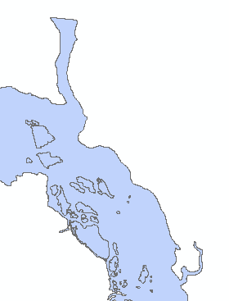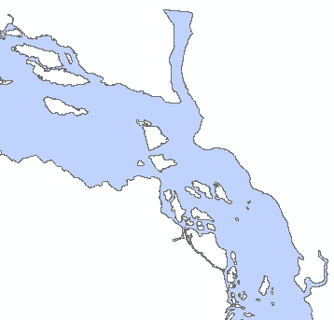

**Before After**

Open the attribute table for the new polygon, sort by Shape_Area and select all but the 1st largest area. Right Click and Delete selected rows. This will remove all the small donut holes and make them open as they should be. However keep in mind that if the geometry should be split across multiple rows, then you should retain all correct polygons that should be flooded. Most of the time it is one large continuous polygon but sometimes it might be split across 2-3.